Big Mountain Resort Recommendation

From the Data Science Team

**Problem Statement**

Big Mountain Resort will validate an increased ticket price by defining and comparing

individual inter-resort aspects/facilities that contribute to the market average before next season as a response to increased operating costs from the added chairlift.

**Results**

The supported market price is $95.87 compared to the current ticket price for BM Resort at $81.

**Data Driven Recommendations**

Depending on each respective operating costs, below are three viable ways to implement the ticket price increase:

* Closing down 10 of the least used runs will result in a decrease in ticket price by $-1.75 and a seasonal loss of over $300,000. (need chairlift operating costs)
* Increasing the vertical drop results in a supported $1.99 increase in ticket price resulting in $3474638 additional revenue per year. (need chairlift operating costs)
* adding 2 acres of snow making results in a supported $1.99 increase in ticket price resulting in $3474638 additional revenue per year. (need snow making upfront, operating and installation costs)

**Further Details**

Last season, Big Mountain Resort added a chairlift to help customers cross the mountain more easily, however, the added operating costs added a $1,540,000 in cost. In response to the decrease in profit margins, Big Mountain Resort would like to determine a data driven solution to increase ticket prices to reflect the full facilities offered at the resort.

The first task of cleaning and prepping the data involves looking into the 330 rows and 27 columns. Our target resort is present in the data and has all its corresponding columns.

We check and correct for null values, duplicates and other unsatisfactory information.

With a clean data set and new, relevant info merged in, the current data is saved in a separate directory to prevent overwriting the original dataset.

So far, we have prepared the data to now be able to explore and get to know it. We will look to use the weekend ticket price and variations of regions, total terrain parks, skiable terrain, days open last year, and night skiing as target features.

First, we can observe that the ticket price is positively correlated to the available night skiing, which suggests offering more night skiing to accommodate a higher ticket price. Runs and number of chairs also greatly influence ticket prices positively. And on top of that, the elevation has a positive effect on ticket price. There are many factors to consider. So, let’s see how the model weighed the final variables:

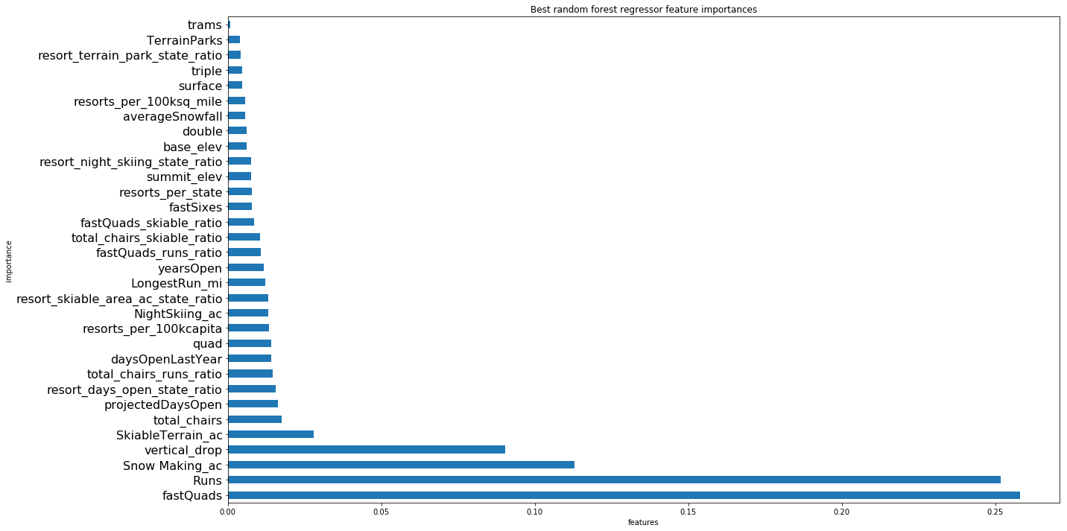

The graph above clearly shows four leading causes for increased ticket price, which might mean that customers are more willing to pay for these features/facilities.

Once we identify these top four, we are able to test different scenarios to determine how each change in feature/facility will affect the predicted market price.

Scenario 1 - Closing down 10 of the least used runs will result in a decrease in ticket price by $-1.75 and a seasonal loss of over $300,000

Scenario 2 & Scenario 3 - increasing the vertical drop and adding 2 acres of snow making, respectively, both result in a supported $1.99 increase in ticket price resulting in $3474638 additional revenue per year.

Scenario 4 - Increasing the longest run by 0.2 miles results in no change in ticket price.

Scenario 4 has no change in price and therefore is dropped.

**Conclusion**

Being that Big Mountain Resort priced their tickets significantly less than market price, it is possible and likely that other resorts have mis-priced their tickets too. With that in mind, the model created and used here has limitations set in the accuracy of its given data.

Also, other scenarios may be viable, however, we chose to test the ones above because of how the model weighted them. There may be other ways to achieve a higher profit margin and account for the increased operating costs of the new chairlifts. For example, terrain parks, is weighted second from last in the model, however, if its operating costs are significantly higher than they are worth in revenue, then closing down a few terrain parks may be another viable solution.

Our recommendations above require a bit more information to make a sound decision, but we believe that this data is a strong mark by which to measure your decision.